HR Leader Toolkit — Communication Tools & Templates
Purpose: The materials in this Word document are designed to be leveraged and modified by each individual agency. HR leaders can use these materials and templates to communicate change both to and through their managers. Managers may then discuss the job classification structure changes with employees by sharing the employee email packet. The personalized employee data sheet within the employee email packet provides employees with their new job code, pay grade and title.
Enclosed:
Manager Email Packet
- Email/Letter to Managers Template
- Talking Points for Managers Communicating Change to Employees with Career Path Example Handouts
- FAQs
Employee Email Packet
- Email/Letter to Employees Template
- Sample Employee Data Sheet
- FAQs
- Statewide Distribution Pay Structure [optional]
Manager Email Packet
- Email/Letter to Managers Template
Purpose: To introduce the Job Classification and Career Path project to managers.
Subject Line: State Job Classification and Career Path Project
DOAS Human Resources Administration Division has partnered with the agencies across the State to standardize the jobs, update the pay structure and set the foundation for developing career paths.
We have reviewed and updated our job classification and pay structures to ensure that we have the right foundation in place to support the integrated talent management efforts across the State. As a result of this work, you and your employees will benefit from having a clearer view of what your career path might look like at the State.
When the new structures are implemented, you will see a change in your job code and pay grade, however, the new structure will not result in any changes to your responsibilities or salary.

Outlined below are the key facts about this important initiative and what it means for you and your employees.
Who? The Department of Administrative Services, Human Resources Administration Division (fulfilling the duties governed by the State Personnel Board Rules) partnered with HR leaders across the State.
What? Our State’s Talent Management initiative had several goals in mind:
  - Update jobs and job classification structure
  - Update pay structure
  - Lay a foundation for career planning
Why? The State’s job classification and pay structures needed to be updated to remain competitive in attracting and recruiting talent in today’s market.
How? We used multiple external salary surveys with market information from public sector, private sector, and consideration of factors such as supply and demand for difficult-to-fill positions and critical skill sets. The result – new jobs and job descriptions which were market priced for every job in the statewide jobs structure.
When? January 1, 2016.
While this doesn’t affect pay or job responsibilities, you’ll be responsible for communicating information about the project to your employees. In addition to this email, we have included talking point and FAQs.
Have a question that’s not answered here? If you have questions that are not included in the attached FAQs, please contact your HR Department.
- Talking Points for Managers Communicating Change to Employees with Career Path Examples
Purpose: To guide manager/employee discussions that arise from the employee email packet announcing changes due to the Job Classification and Career Path project.
Subject Line: State Job Classification and Career Path Project
- DOAS Human Resources Administration Division has partnered with the agencies across the State to standardize the jobs, review the pay structure and set the foundation for developing career paths.
- There will be new job classification and pay structures in place.
- Everyone will have a new job code and pay grade. However, there will be no impact on employee salaries or job responsibilities as a result of the new structures.
- To better understand these changes, I’d like to share an example of the new job classification structure by showing you a sample job family – in this case, Human Resources. [Show sample HR career path example]
- Within the job family, jobs are grouped first into a job function – management, professional, technician or admin/support and a job series (or group of jobs) that share similar duties or responsibilities and require similar experience or competencies.
- In HR, those groupings might include generalists, managers, and technicians, for example.
- Within each of the job series, there are levels that mark the progression of a career – in terms of added expertise or responsibility.
- The levels in a job series give you an idea of how your career path might look at the State.
- This is just one example of the job classification structure; we also have examples in three other job families: Education, Law Enforcement and Health Care.
Career Path Examples
Human Resources Job Family – HR Generalist Career Path Example
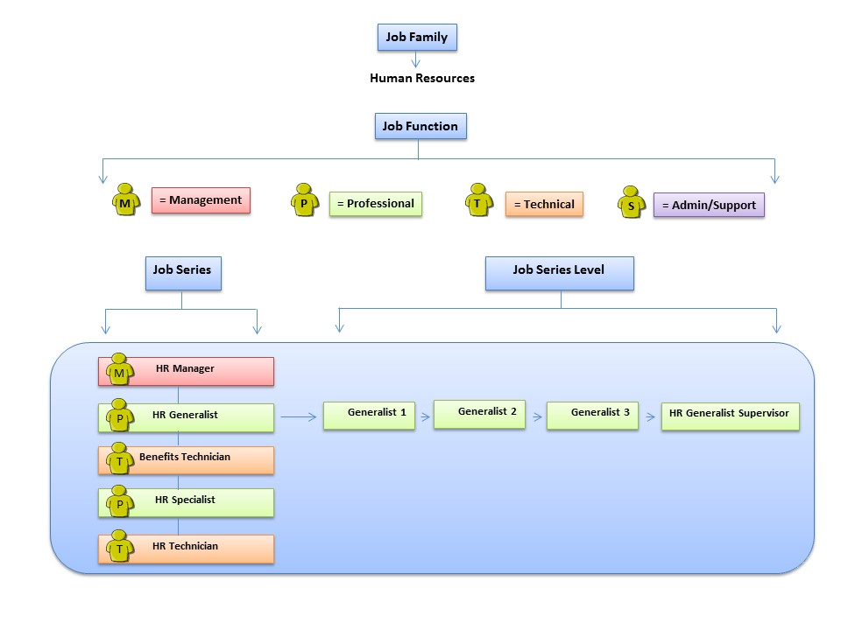

Employee Email Packet
- Email/Letter to Employees Template
Purpose: To introduce the Job Classification and Career Path project to employees.
Subject Line: State Job Classification and Career Path Project
DOAS Human Resources Administration Division has partnered with the agencies across the State to standardize the jobs, update the pay structure and set the foundation for developing career paths.
We have reviewed and updated our job classification and pay structures to ensure that we have the right foundation in place to support the integrated talent management efforts across the State. As a result of this work, you will benefit from having a clearer view of what your career path might look like at the State.
When the new structures are implemented, you will see a change in your job code and pay grade, however, the new structure will not result in any changes to your responsibilities or salary.
Please find attached your personalized employee data sheet as well as frequently asked questions.
Have a question that’s not answered here? If you have questions that are not included in the attached FAQs, please contact your HR Department.
Enclosed:
- Sample Employee Data Sheet
- FAQs
- Statewide Distribution Pay Structure [optional]

- Sample Employee Data Sheet
Dear [Employee]:

The Department of Administrative Services, Human Resource Administration Division has partnered with the agencies across the state to standardize the jobs, update the salary structure and set the foundation for developing career paths. We have reviewed and updated our job classification and pay structures to ensure that we have the right foundation in place to support the integrated talent management efforts across the state.

As a result of this work, you will benefit from having a clearer view of what your career path might look like at the state. When the new structures are implemented January 1, 2016, you will see a change in your job code and pay grade as outlined below. The new structure will not result in any changes to your responsibilities or salary.

State Job Classification and Career Path Project
Personalized Employee Data Sheet

Employee Name: [x]

Agency: [x]

Department: [x]

Manager's Name: [x]

New Job Code:  Each job is part of a “job series” which provides a potential career path based on your current job, skills and experience | [x] | Old Job Code: | [x]
New Pay Grade:  Your pay grade is associated with a salary range | [x] | Old Pay Grade: | [x]
New Job Title (if applicable):  Your new job title will also appear on your pay stub | [x] | Old Job Title: | [x]

If you have any questions, please contact your HR Department.
- FAQs (for both Managers and Employees)
Please see below for a list of frequently asked questions. The questions are organized by category:
- About Changes
- Job Classification Structure
- Job and Position Descriptions
- Compensation
Have a question that’s not answered here? If you have questions that are not included in the FAQs, please contact your HR Department.
About Changes
- Why is the State updating its job classification and pay structures?
We are updating our job classification and pay structures to ensure that we have the right foundation in place to support programs that are competitive, consistent and compliant with our policies. The changes will also help us manage our talent needs efficiently and effectively. We see this as the start to providing a clearer view of what your career path might look like at the State.

- Who provided input to this update process?
The Department of Administrative Services (DOAS) led initiatives to help update the job classification and pay structures. HR Leaders, agencies and communities of interest all had input.

- What changes for me as a result of these updates?
You will have a new job code and pay grade. Your job responsibilities and pay will not change as the result of these structure updates. With the job classification structure update, we have created clear levels that mark growth in responsibilities and expertise, so there’s a job series for each job that shows how you can progress in your career.

- Will my salary change as a result of my new job code and pay grade?
No, your salary will not change as a result of implementing the new job codes and pay grades.

- My salary is below the minimum for my salary range. Will I be brought up to minimum?
Agencies will monitor and address salary changes within their budget constraints.

- My salary is above the maximum for my salary range. Will I be brought down to maximum?
The implementation of the new structure will not result in your pay changing. While agencies may establish their own salary administration policies and practices, implementation of this structure will not have any impact on your current pay.

- What is a pay grade?
Each job is assigned to a pay grade based on the job’s content (responsibilities, qualifications) compared to the market rate. Pay grades are linked to a salary range in the Statewide Distribution (SWD) pay structure. Each job is assigned to a grade based on the value of similar jobs in the external marketplace and across the State’s agencies.

- Are all pay grades changing?
Yes, everyone’s pay grade will change. That’s because the State has simplified the Statewide Distribution pay structure and created more differentiation (less overlap) between the salaries ranges associated with each grade. This means jobs at different levels have more distinct differences in salary opportunities. The pay structure is also moving from numeric to alphabetical pay grades – reinforcing the fact that all the pay grades are new.

- Is my new pay grade higher or lower than my current pay grade?
The new pay grades are structured to be alphabetical rather than numerical – and we have fewer pay grades than in the past, so there’s not a clear comparison between your old and new pay grades.

- Why is the State changing the pay grades?
The overlap in the existing salary ranges makes it hard to determine which pay grade to use for some of our positions. In our review, we found that similar jobs were assigned to more than one pay grade –resulting in different pay in different agencies for what was virtually the same job. The new grades allow for clearer distinction in salary ranges. We are moving from a numeric to an alpha pay grade to reinforce the fact that all the pay grades are new.

- How can I learn more about my career path opportunities?
Please consult with your supervisor or HR Department. After the implementation is complete, you will have access to additional job information through the DOAS website. Information will include identification of career paths within each job series, as applicable.
Job Classification Structure
- What are the key elements of the job classification structure?
- Job Family … Job families are the broadest category used to organize jobs – they represent “industry areas” and often cut across agencies
- Job Series … Each job family may include several job series – each including similar duties or responsibilities, and requiring similar experience or competencies
- Job Descriptions … outlining the job’s basic responsibilities/duties and qualifications
- Job Function (Management, Professional, Technician, or Admin/Support) and Job Series Level…the levels in a job series give you an idea of how your career path could look
- Job Title (basic name for job and a code that identifies job family, function, sub-function)

- What are the benefits of using a job classification structure?
Using a job classification structure:
- Establishes the principle of equal pay for substantially equal work
- Provides a tool for organizing the work and identifying the knowledge and skills needed to accomplish an organization’s mission
- Assists in management activities – things like recruiting, designing an organization, setting performance standards
- Offers a basis for recruiting, placing, compensating, training, reassigning and promoting employees
Job and Position Descriptions
- What’s the difference between a “job” and a “position”?
- “Jobs” are established at the State level – to outline core responsibilities/duties and qualifications for jobs at similar levels with similar focus. They provide a foundation for managing career opportunities and pay in a consistent way across all State entities.
- “Positions” exist at the agency level – to provide a way for agencies to describe the specific responsibilities and experience required for a job within the agency. Each agency “position” relates back to a “job” and a job code at the State level.
For example: The State has a General Office Clerk job. That job relates to a variety of agency positions – each with some unique responsibilities and experience related to the agency.
- Do job and position descriptions just focus on responsibilities/duties and qualifications?
Job and position descriptions also include information about job function and job series level, job code and pay grade.

- How are job and position descriptions used?
Job and/or position descriptions are used in recruiting, in the performance management process, and in having discussions with employees about career opportunities. Job descriptions and job codes are also used to price the value of a job for pay purposes. Each job code is linked to a pay grade in the pay structure.
Compensation
- Why does the State have a Statewide Distribution pay structure?
Our pay structure defines the range of base salary possibilities for a job, and ensures that we value jobs in a way that is competitive in the marketplace and consistent across the enterprise.

- What is a pay grade?
Each job is assigned to a pay grade based on the job’s content (responsibilities, qualifications) compared to the market rate. Pay grades are linked to a salary range in the Statewide Distribution (SWD) pay structure. Each job is assigned to a grade based on the value of similar jobs in the external marketplace and across the State’s agencies.

- How does the State assign jobs to pay grades?
Jobs are assigned to pay grades based on a review of:
- External value of jobs – based on similar positions in comparable public entities, private companies (as appropriate), and regional market factors
- Internal job value – to ensure consistent, equitable administration of pay across the organization

- How do I determine the appropriate hiring rate for a position at my agency?
Each position at the agency level is tied into a job code and a pay grade at the State level. That pay grade provides you with the salary range for that position. Each pay grade has a minimum, a maximum and a point in between that corresponds with the average market for jobs in that grade. The State, like most organizations, allows flexibility for setting a new employee’s pay rate based on market conditions and/or the new employee’s credentials. Generally, new employees are hired between the minimum and market value – closer to the minimum when not fully competent or proficient in the job, closer to the market value when fully competent and proficient.

Statewide Distribution Pay Structure FY 2016
JCCP Statewide Distribution Pay Structure
New Grade | Minimum | Market Average | Maximum
A | $15,080 | $20,346 | $23,499
B | $16,000 | $21,973 | $25,379
C | $16,919 | $24,170 | $27,917
D | $18,611 | $26,588 | $31,639
E | $20,472 | $29,246 | $34,803
F | $22,520 | $32,171 | $38,283
G | $24,772 | $35,388 | $43,350
H | $27,249 | $38,927 | $47,685
I | $29,974 | $42,819 | $52,454
J | $32,971 | $47,101 | $57,699
K | $36,268 | $51,812 | $63,469
L | $40,983 | $58,547 | $71,720
M | $46,311 | $66,158 | $81,044
N | $52,331 | $74,759 | $91,579
O | $59,134 | $84,477 | $103,485
P | $66,822 | $95,459 | $116,938
Q | $75,508 | $107,869 | $132,140
R | $85,325 | $121,892 | $149,318
S | $96,417 | $137,738 | $168,729
T | $108,951 | $155,644 | $190,664

The Law Enforcement Pay Structure FY 2016
Law Enforcement Pay Structure
New Grade | LE Minimum | Market Average | LE Maximum
LC | $18,916 | $22,699 | $30,265
LD | $20,561 | $24,673 | $32,897
LE | $22,348 | $26,818 | $36,875
LF | $24,292 | $29,150 | $41,296
LG | $26,991 | $32,389 | $45,884
LH | $29,690 | $35,628 | $50,473
LI | $32,659 | $39,191 | $55,520
LJ | $35,925 | $43,110 | $62,868
LK | $39,877 | $47,852 | $69,784
LL | $44,263 | $53,116 | $77,460
LM | $49,132 | $58,958 | $85,981
LN | $54,536 | $65,444 | $95,439
LO | $61,081 | $73,297 | $106,891
LP | $68,410 | $82,093 | $119,718
LQ | $76,620 | $91,944 | $134,084
LR | $85,814 | $102,977 | $150,175
LS | $96,112 | $115,334 | $168,196

